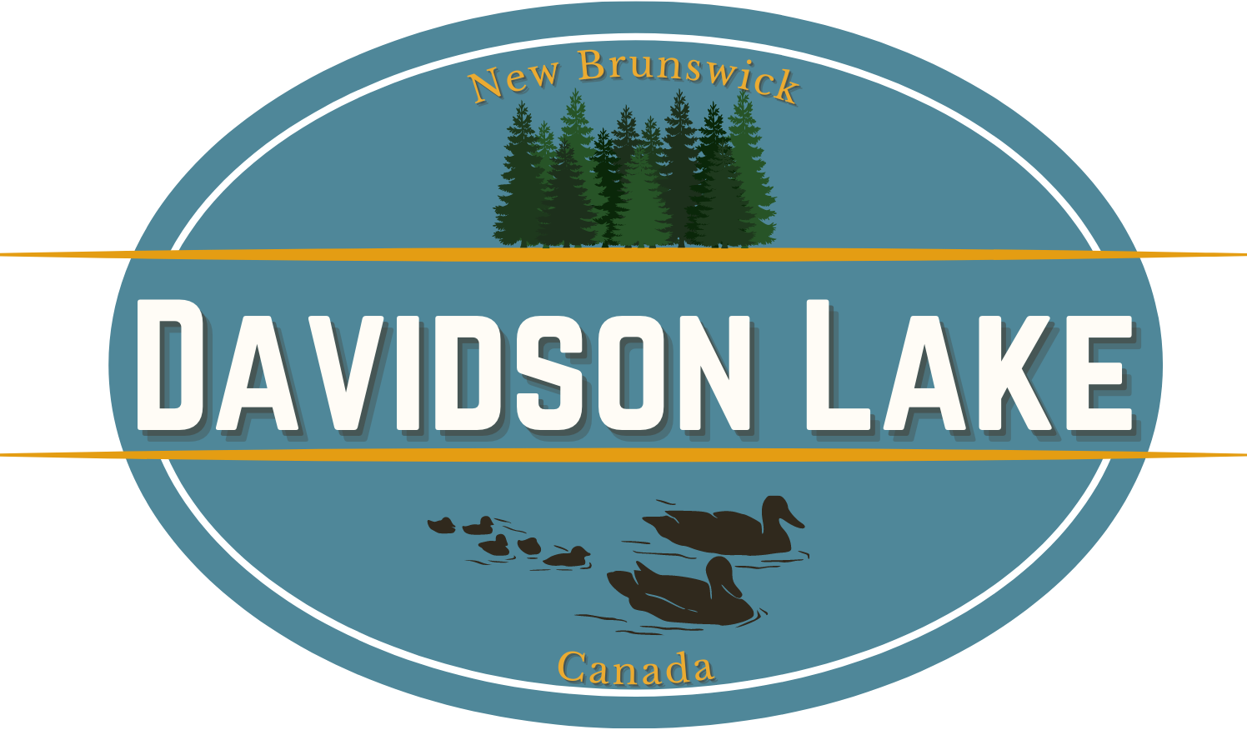

Davidson Lake Association
Annual General Meeting
July 8th, 2023
Minutes

Megan Wilkins called the meeting to order at 10:35 am and welcomed everyone to the 2023 Davidson Lake Association Annual General Meeting

The motion was made by Mac Wilson to accept the AGM Agenda
Seconded by Brian Hayden
Motion Passed

The motion was made by Brian Hayden to accept the minutes.
Seconded by Janet Morton
Motion Passed

Financial Updated by Jeanne Sayer
Jeanne reviewed the Financial Breakdown slide presented to the audience.
The motion was made by Brian Hayden to accept the financial review.
Seconded by Roger Swartz
Motion Passed

Budget Breakdown by Jeanne Sayer
Jeanne reviewed the Budget Breakdown slide presented to the audience.
The motion was made by Mac Wilson to accept the budget breakdown review.
Seconded by Brent Henley
Motion Passed

Update on Roads & Trails by Megan Wilkins
Megan reviewed the Roads slide presented to the audience. A special “Thank You” to Ken Donald for his dedication to the work of the roads here at the lake.
No questions from the audience.

Note: Any assistance with maintenance of the trails would be appreciated.

New Brunswick Alliance of Lakes Association Update by Arnie Wilkins
Arnie presented an update on the NBALA. He covered the 4 areas of testing which are dissolved oxygen, PH, temperature and conductivity. All levels are within normal parameters.
Arnie presented a report of the last years of testing for the lake, and also compares these tests to all other lakes in that are members of the NBALA. Currently Davidson Lake is “middle of the pack.”
Arnie also presented a bathymetry map showing the various depths of the lake and explained the advantages of the deep water hole and how that, along with the fact this is a spring fed lake, helps with keeping the water healthy.

Note: Any assistance with the testing of the lake would be appreciated.
Question: A post was made in the Davidson Lake Facebook group about someone seeing blue green algae in the lake. Was it blue algae? Arnie wasn’t sure.
Question: If it was, is there a cure for it? Arnie said no.
Question: Is the input and output of the water still a concern? Arnie stated not a concern, water levels are fine.

Fundraising and Community by Megan Wilkins
Megan reviewed the Fundraising and Community slide presented to the audience. A special thank you to Aunden Rae was mentioned for his donation of the materials for the new bench at the beach and for his help with getting the new sign.
Question: Who cleans the garbage shed? Megan stated that there was no set list, volunteer basis. Barb Boyd said she would like to volunteer to do that.

Megan opened the floor for questions. A question was raised on concern for the lake levels. Megan indicated that this was due to the fact that the beavers have returned, and there has been a high amount of rain this year. She indicated that the association is keeping an eye on the levels and will reach out to other lakes in the NBALA should there be any concerns. There was mention of concerns of erosion, it was acknowledged that these high water levels are contributing to a form of erosion, but the Association will work with experts, as they have in the past to address any major concerns if they arise.

Jeanne Sayer made a motion to audit for the financials for transparency purposes.
This was moved by .
Seconded by __who?____________
Motion passed.

Election
3 calls were made for any nominations on the floor for the committee.
Voted in were:
- Megan Wilkins, President
- Dan Debow, Vice President
- Jeanne Sayre, Treasurer
- Lisa Howe, Secretary
No new nominations.

3 calls were made for the Board of Directors.
Brian Hayden nominated Susan Hayden
Barb Boyd nominated Diane Upshaw
Elected Board members were:
- Arnie Wilkins
- Ken Donald
- Aunden Rae
- Chelsea Whidden
- John Prime
- Susan Hayden
- Diane Upshaw
Megan, I will need help with this Election section.

A motion was made by Greg Gallagher to close the meeting.
Seconded by Mac Wilson
Motion passed.

Meeting closed at 11:45 am

Hotdog Social to follow (Donated & Hosted by Bible Camp)

