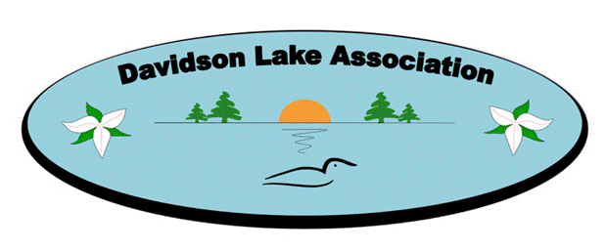

Minutes
Davidson Lake Association
Board of Directors’ Zoom Virtual Meeting
March 10, 2022

Attendees:
Megan Wilkins, Arnie Wilkins, Jeanne Sayre, Ken Donald, Aunden Rae, Chelsea Whidden, Dan Debow, John Prime

Absent:
Tina Hagerman-Peddle, Claude Tremblay, Derek Odgen, Mike Gardiner

Davidson Lake Association (DLA) Board of Directors’ Zoom Virtual Meeting was held on Thursday, March 10, 2022 at 7:00 p.m. chaired by President, Megan Wilkins.

Motion: Motion to accept the agenda as presented by exception. Agenda accepted.

Motion: Minutes of the January 2022 Board of Director’s meeting were provided prior to the meeting. Motion to approve the minutes as presented by exception. Minutes approved.

Financial Update – Claude Tremblay
Submission was made to SNB. No report available.

Water Committee – Dan Debow
Arnie advised the Portal is not user friendly and may change to a different database. He will assist Dan once new system is established.

NBALA – Arnie Wilkins
Specialist in analyzing fresh water systems has moved to Grand Lake. The NBALA has reserved funds to obtain his services to get a profile of Harvey Lake. More details will be available after the upcoming meeting. No further update at this time.

Road Committee Update – Claude Tremblay
Ken has inquired about a potential contact to complete the grading in the spring, his name is also Charlie.

Garbage/Recycling Sheds – Megan Wilkins
Megan has not been able to reach contact by phone – mailbox is full. Ken will stop by and touch base with our contact regarding the idea of a new shed. No information is available at this time regarding the LSD merger.

Lake Swag – Megan Wilkins
Megan contacted the printer and the minimum order is 12 shirts. Our cost would be $30 sweatshirts, $15 t-shirts, $15 hats. The logo will be printed on the back with a DL logo on the front. Order will be placed for the board of directors in preparation of the summer kickoff event in June. We will be able to take orders from lake residents to place a bulk order in July.
Action item: Megan to create a proposal on pricing to generate profit off the sales

New Lake Logo - MeganWilkins
Tasha Trefry volunteered to create a few logo options for the association. Discussion took place on what logo options to select. Decision was made to include Canada rather than Association to be more inclusive to all lake residents. No objections.
Action item: Megan to discuss with the printer on which group of trees will print the best and have them made the selection.

Fundraising Proposal – Megan Wilkins
Megan had emailed the group a proposal with the tiers and prizes. Jeanne made a motion to accept the proposal and seconded by Arnie. Megan will begin the planning of a virtual campaign to begin early to mid-May using the website and social media. Posters will also be created for the local bulletin board and garbage shed. A “welcome to summer” brochure will also be created to share this information.

Website – Megan Wilkins
Tasha Trefry has volunteered to assist with maintaining the website. She has some ideas for concepts.
Action item: Megan will present some drafts at the next meeting.

Lake Activities/Community Events
Claude had previously made the suggestion to have a “hotdog social” in June to welcome back the summer lake residents. This is also an opportunity to accept new memberships and take orders for “lake swag”. What other events can we do? Davidson Lake day? Movie night? Can we coordinate with Dumfries Days?
Action item: All board members to brain storm to create a repository of options to implement during the summer to create engagement with lake residents.

Social Media/Instagram – Jeanne Sayre
Suggestion was made that we establish a Davidson Lake Instagram account. The goal is to provide information about what is happening at the lake by way of pictures and by engaging with the youth. Jeanne’s daughter Emily has volunteered to create the account and posts. The board would determine who would have moderator access. Megan made a motion to create the Instagram page and Arnie seconded the motion. Emily to create an Instagram page.

Round Table:
Ken expressed his concern around the LSD merger and the implications of the snow removal. Arnie echoed his concerns indicating this merger would also impact the garbage pickup. There are lots of questions on the impact of the merger.

Next Meeting
The next DLA Bd. of Directors’ Meeting via Zoom is scheduled for Thursday, April 14, 2022 at 7:00 p.m.
Motion made by Arnie to adjourn. The meeting was adjourned at 7:35 p.m.

Jeanne Sayre, Secretary

