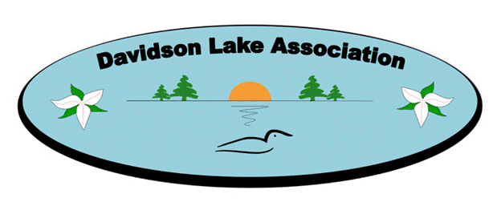

Minutes
Davidson Lake Association
Board of Directors’ Zoom Virtual Meeting
April 15, 2022

Attendees:
Megan Wilkins, Arnie Wilkins, Jeanne Sayre, Claude Tremblay, Mike Gardiner, Dan Debow

Absent:
Tina Hagerman-Peddle, John Prime, Ken Donald, Aunden Rae, Chelsea Whidden, Derek Odgen

Davidson Lake Association (DLA) Board of Directors’ Zoom Virtual Meeting was held on Thursday, April 15, 2022 at 7:00 p.m. chaired by President, Megan Wilkins.

Motion: Motion to accept the agenda as presented by exception. Agenda accepted.

Motion: Minutes of the March 2022 Board of Director’s meeting were provided prior to the meeting. Motion to approve the minutes as presented by exception. Minutes approved.

Financial Update – Claude Tremblay
Year-end statement shared. Collections were lower due to no membership drive.

Water Committee – Dan Debow
No update at this time.

NBALA – Arnie Wilkins
Septic committee has not met, but is scheduled to meet in May.
Invasive Plant Control project - Looking for a person to train volunteers.
Water monitoring portal – no change
Wash station is rolling out this year and will be located where there are fishing tournaments.
AGM will be held in early June via Zoom and all will be invited to attend.
Membership to the NBALA is due for renewal.
Action Item: Arnie to send membership renewal information to Claude for payment.

Road Committee Update – Ken Donald (presented by Megan)
Back up grader, Charlie Lindsay, has been established if needed. Quote will be provided once the road dries and settles. There has been a ditch collapse along Scott Lane that will need to be fixed.

Garbage/Recycling Sheds – Megan Wilkins
Fero has left several notes regarding the condition of the garbage shed. Discussion held on how to encourage community to keep it clean. Jeanne suggested garbage bags be provided inside the shed to deter loose garbage being left. Claude advised there is a camera that can be hooked up. Megan suggested a public appeal highlighting the Association is about community. It is important to acknowledge the residents who are working hard to keep the shed clean.
Action Item: Claude to hook up camera and sign
Action Item: Megan to purchase and provide garbage bags in the shed. In addition, a public appeal will be posted on Facebook. Fero to be contacted to establish large item pick up schedule for the summer.

Lake Swag – Megan Wilkins
Action item held over: Megan to create a proposal on pricing to generate profit off the sales

New Lake Logo - MeganWilkins
Logos have been sent to the printer. No decision has been made by the printer on which group of trees will print the best.

Fundraising
Claude would like to continue with door-to-door canvassing to obtain road donations and memberships in addition to the virtual campaign to begin early to mid-May. Need to establish “what’s in it for me” – currently the yearly $10 membership provides members with a lake directory. Volunteers to assist with this canvassing to contact Claude.
Action Item: Dan to look into having the directory updated and printed.

Website – Megan Wilkins
Photos have been collected and provided to Tasha. No update at this time.
Action item held over: Megan will present some drafts at the next meeting.

Lake Activities/Community Events
Hotdog social would provide free hotdogs to members. Want to encourage memberships and road donations.
“Welcome to Summer” pamphlet is being created to share what is planned for the summer including our membership and road committee fundraisers.
Dumfries Days are being held this year with washer toss tournament and parade.
Action item: Arnie to follow up with the coordinator of Dumfries Days to obtain more information on what is planned and how we can participate.
Action Item: Megan to contact Gary at the Bible camp to see if we can have the membership appreciation event a.k.a. hot dog social at their facility as they have a kitchen.
Action Item: Megan to have pamphlet ready for May distribution.

Round Table:
No comments

Next Meeting
The next DLA Bd. of Directors’ Meeting via Zoom is scheduled for Thursday, May 12, 2022 at 7:00 p.m.
Motion made by Mike to adjourn. The meeting was adjourned at 7:55 p.m.

Jeanne Sayre, Secretary

