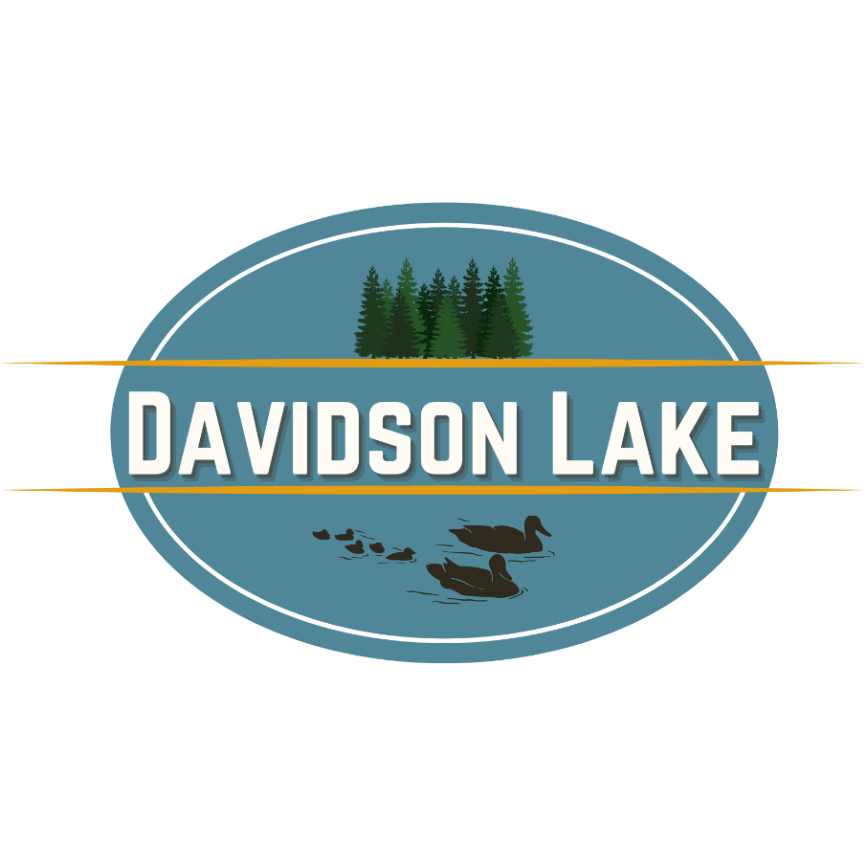 |  | Clean, Drain, Dry Program
CLEAN DRAIN DRY (CDD) is a public awareness campaign aimed at preventing the introduction and spread of aquatic invasive species. It is a call-to-action encouraging the users of New Brunswick’s lakes, rivers, and coastlines to CLEAN, DRAIN, and DRY their boats, trailers, and other recreational equipment to stop ‘aquatic hitchhikers’

Before entering Davidson Lake, please follow the Clean, Drain, Dry protocol:
- Clean: Remove all visible debris from watercraft and gear
- Drain: Empty all water from bilges, coolers, and compartments
- Dry: Let everything dry thoroughly for at least 24 hours before use
This applies to all watercraft and gear — even if you’ve only used them in another NB lake.

Welcome to Davidson Lake!  The Association  We are an organization focused on the betterment of Davidson Lake and the environment around it. This includes educating people on protecting the quality of our water, its accompanying watershed and our community for present and future generations.  CONTACT  WEBSITE:  www.davidsonlake.ca  EMAIL:  davidsonlakenb@gmail.com |  | Help us protect from invasive species
Eurasian Milfoil and Zebra Mussels are two invasive aquatic species already present in parts of New Brunswick. They spread easily and can devastate lake ecosystems.

These invaders can hitch a ride on:
- Boats and trailers
- Paddleboards, kayaks, canoes
- Life jackets, wetsuits, and water shoes
- Fishing gear and paddles
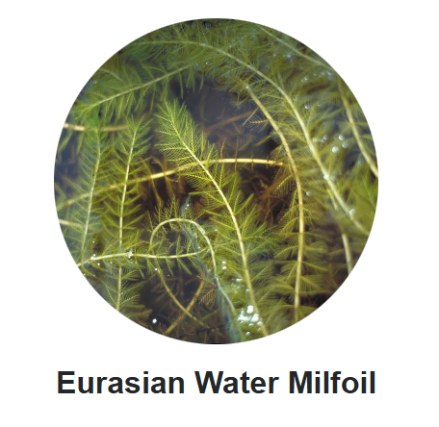
Once introduced, they are nearly impossible to remove. 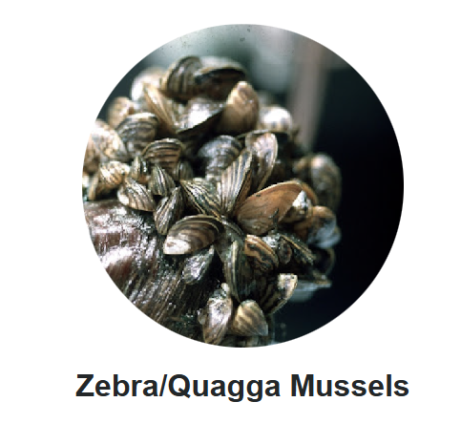

 |  | phosphate free initaitve
Phosphates from soaps, detergents, and shampoos contribute to algae blooms and poor water quality.
Please use phosphate-free products during your stay. Every small action helps protect the lake.

